**Project Planning Phase**

**Project Planning Template (Product Backlog, Sprint Planning, Stories, Story points)**

|  |  |
| --- | --- |
| Date | 22 October 2022 |
| Team ID | PNT2022 TMID15764 |
| Project Name | Inventory Management System for Retailers |
| Maximum Marks | 8 Marks |

**Product Backlog, Sprint Schedule, and Estimation (4 Marks)**

Use the below template to create product backlog and sprint schedule

|  |  |  |  |  |  |  |
| --- | --- | --- | --- | --- | --- | --- |
| **Sprint** | **Functional**  **Requirement (Epic)** | **User Story**  **Number** | **User Story / Task** | **Story Points** | **Priority** | **Team Members** |
| Sprint-1 | Registration | USN-1 | As a user, I can register for the application by using my email & password and confirming my login credentials. | 3 | High |
| Sprint-1 |  | USN-2 | As a user, I can login through my E-mail. | 3 | Medium | M.Mukesh ,P .Rajesh, P Mahesh, P Karthik |
| Sprint-1 | Confirmation | USN-3 | As a user, I can receive my confirmation email once I have registered for the application. | 2 | High | M Mukesh , P Rajesh P .Mahesh, P karthik |
| Sprint-1 | Login | USN-4 | As a user, I can log in to the authorized account by entering the registered email and password. | 3 | Medium | M Mukesh , P Rajesh P .Mahesh, P karthik |
| Sprint-2 | Dashboard | USN-5 | As a user, I can view the products that are available currently. | 4 | High | M Mukesh , P Rajesh P .Mahesh, P karthik |
| Sprint-2 | Stocks update | USN-6 | As a user, I can add products which are not available in the inventory and restock the products. | 3 | Medium | M Mukesh , P Rajesh P .Mahesh, P karthik |
| Sprint-3 | Sales prediction | USN-7 | As a user, I can get access to sales prediction tool which can help me to predict better restock management of product. | 6 | Medium | M Mukesh , P Rajesh P .Mahesh, P karthik |
| Sprint-4 | Request for customer care | USN-8 | As a user, I am able to request customer care to get in touch with the administrators and enquire the doubts and problems. | 4 | Medium | M Mukesh , P Rajesh P .Mahesh, P karthik |
| Sprint-4 | Giving feedback | USN-9 | As a user, I am able to send feedback forms reporting any ideas for improving or resolving any issues I am facing to get it resolved. | 3 | Medium | M Mukesh , P Rajesh P .Mahesh, P karthik |

**Project Tracker, Velocity & Burndown Chart: (4 Marks)**

|  |  |  |  |  |  |  |
| --- | --- | --- | --- | --- | --- | --- |
| **Sprint** | **Total Story Points** | **Duration** | **Sprint Start Date** | **Sprint End Date (Planned)** | **Story Points**  **Completed (as on**  **Planned End Date)** | **Sprint Release Date (Actual)** |
| Sprint-1 | 11 | 6 Days | 24 Oct 2022 | 29 Oct 2022 | 11 | 29 Oct 2022 |
| Sprint-2 | 7 | 6 Days | 31 Oct 2022 | 05 Nov 2022 | 7 | 05 Nov 2022 |
| Sprint-3 | 6 | 6 Days | 07 Nov 2022 | 12 Nov 2022 | 6 | 12 Nov 2022 |
| Sprint-4 | 7 | 6 Days | 14 Nov 2022 | 19 Nov 2022 | 7 | 19 Nov 2022 |

**Velocity:**

Imagine we have a 10-day sprint duration, and the velocity of the team is 20 (points per sprint). Let’s calculate the team’s average velocity (AV) per iteration unit (story points per day)

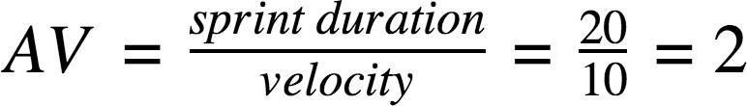

Our velocity should be:

*AV* **=** (𝟏𝟏+𝟕+𝟔+𝟕) **=** 𝟑𝟏 **= 1.29**

𝟐𝟒 𝟐𝟒

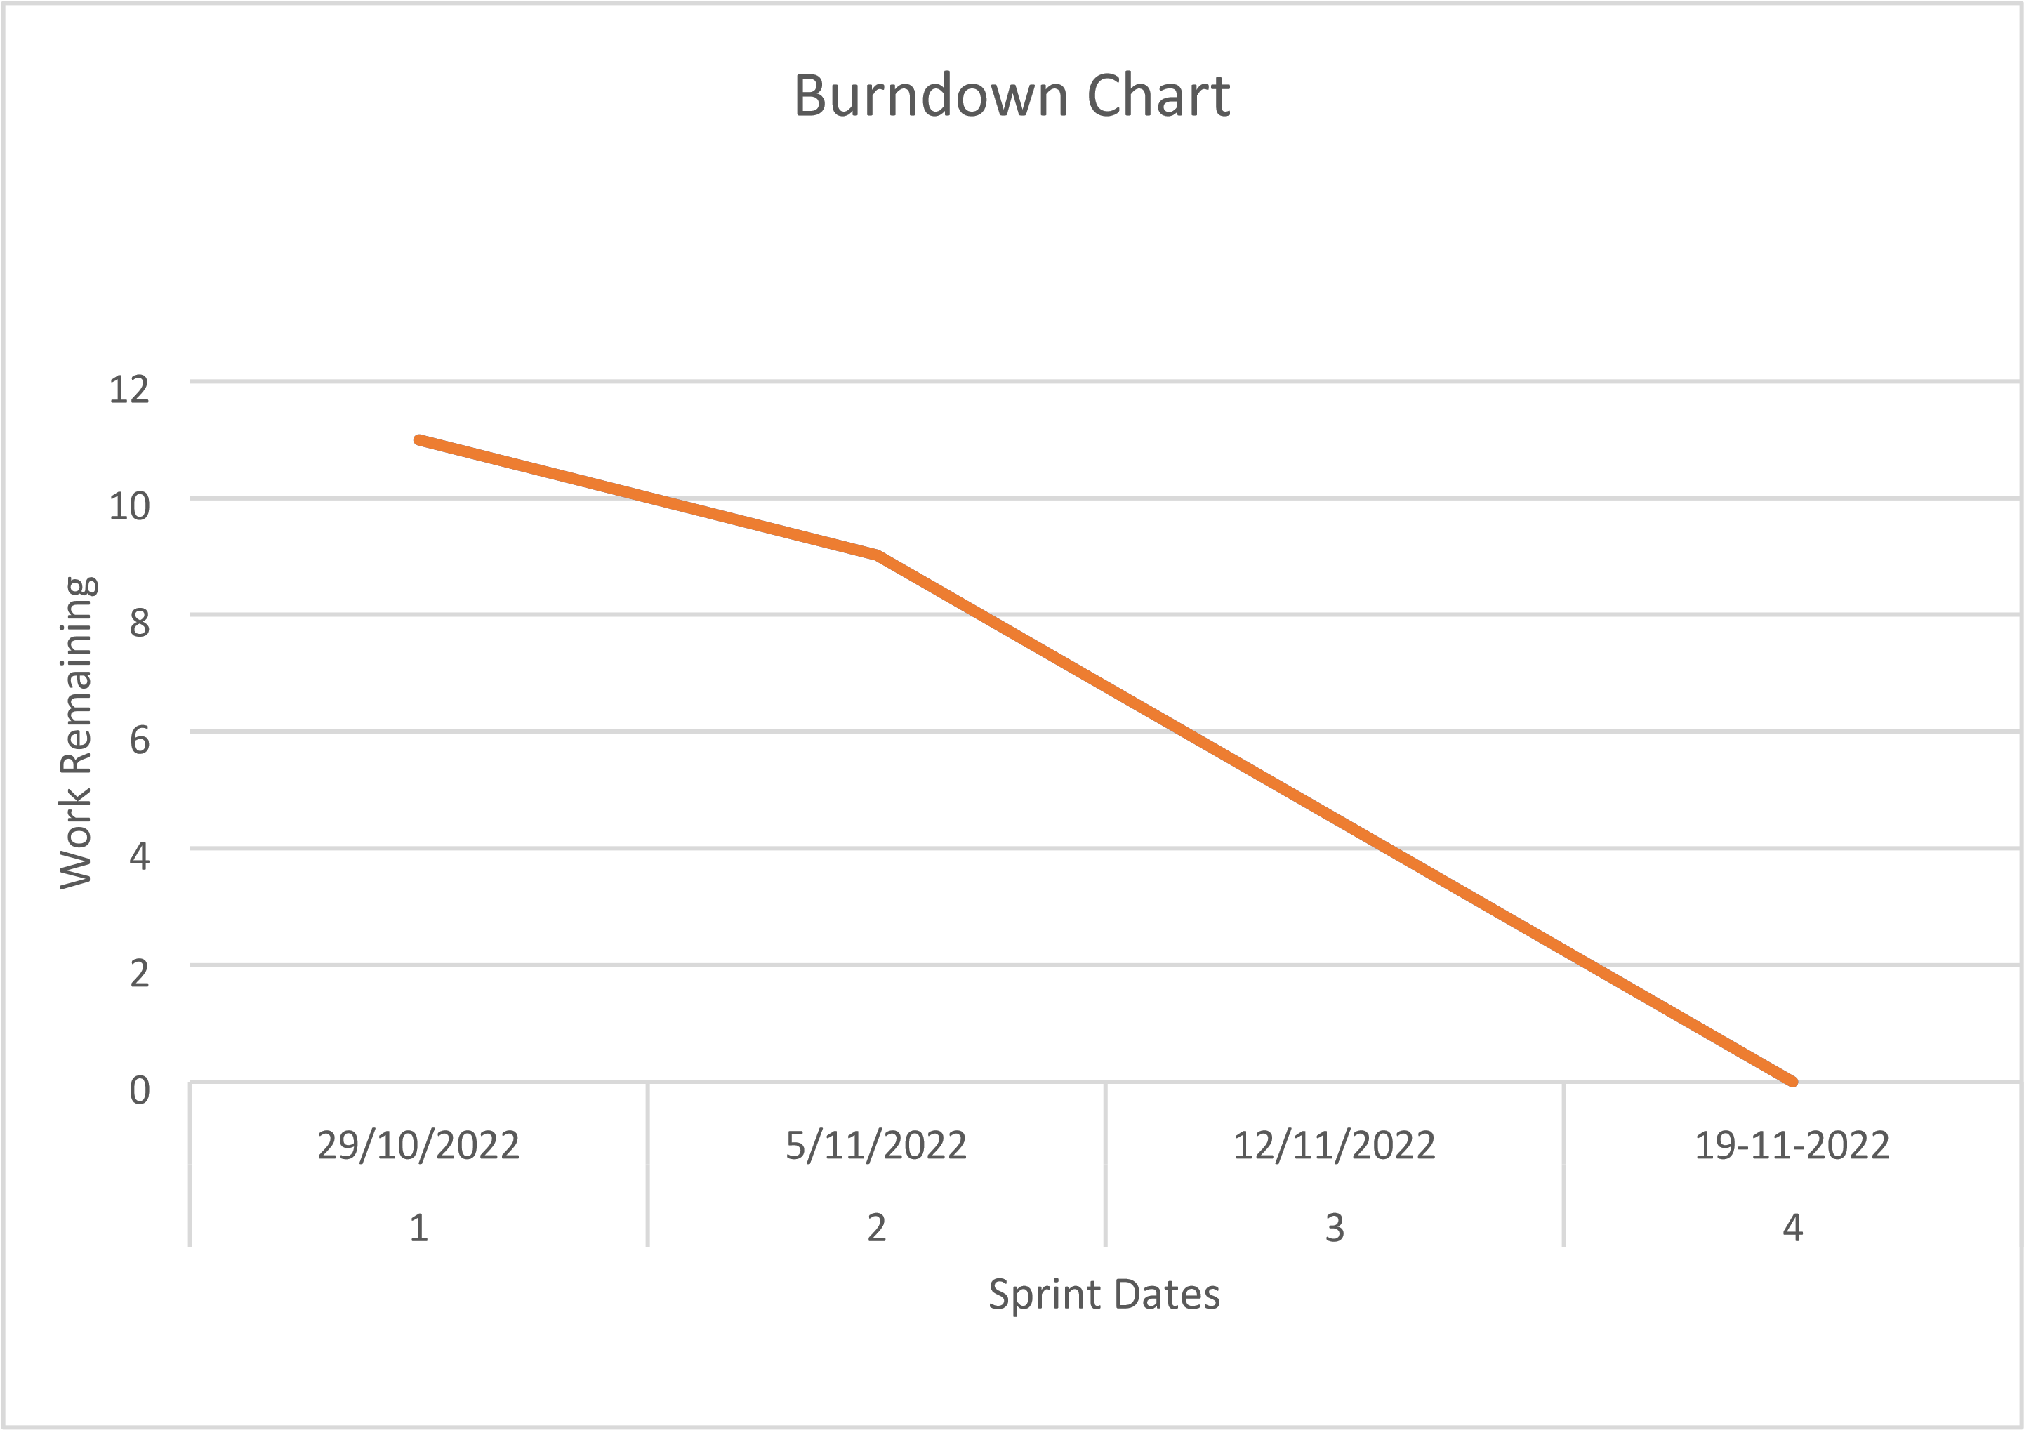

**Burndown Chart:**

A burn down chart is a graphical representation of work left to do versus time. It is often used in agile [software development me](https://www.visual-paradigm.com/scrum/what-is-agile-software-development/)thodologies such as [Scrum.](https://www.visual-paradigm.com/scrum/scrum-in-3-minutes/) However, burn down charts can be applied to any project containing measurable progress over time.

[**https://www.visual-paradigm.com/scrum/scrum-burndown-chart/**](https://www.visual-paradigm.com/scrum/scrum-burndown-chart/) [**https://www.atlassian.com/agile/tutorials/burndown-charts**](https://www.atlassian.com/agile/tutorials/burndown-charts)

**Reference:** [**https://www.atlassian.com/agile/project-management**](https://www.atlassian.com/agile/project-management) [**https://www.atlassian.com/agile/tutorials/how-to-do-scrum-with-jirasoftware**](https://www.atlassian.com/agile/tutorials/how-to-do-scrum-with-jira-software) [**https://www.atlassian.com/agile/tutorials/epics**](https://www.atlassian.com/agile/tutorials/epics) [**https://www.atlassian.com/agile/tutorials/sprints**](https://www.atlassian.com/agile/tutorials/sprints) [**https://www.atlassian.com/agile/project-management/estimation**](https://www.atlassian.com/agile/project-management/estimation) [**https://www.atlassian.com/agile/tutorials/burndown-charts**](https://www.atlassian.com/agile/tutorials/burndown-charts)

**https://careereducation.smartinternz.com/Student/guided_project_workspa ce/47838**